Jonathan Wallis
Rauschenberg, Robert (1925-2008)
Robert Rauschenberg (Milton Ernest Rauschenberg) was an American artist who pioneered new approaches to art prototypical of the Pop Art movement and postmodernism. Born 22 October 1925 in Port Arthur, Texas, Rauschenberg attended the Kansas City Art Institute and the Académie Julien in Paris. From 1948-1952, while attending sessions at Black Mountain College in North Carolina, Rauschenberg studied under the BAUHAUS painter JOSEF ALBERS and the musical composer JOHN CAGE, both of whom became important influences. The experimental approaches encouraged at Black Mountain College informed Rauschenberg’s artistic philosophy and broadened his practice to include dance-theatre and performance.
In the 1950s, while living in New York City, Rauschenberg began incorporating vernacular materials into his paintings including newspapers, textiles and found objects. Experimenting with conceptual strategies and motivated by a Cage-inspired aesthetic, Rauschenberg disregarded the established hierarchies of modern art concerning medium specificity and visual subject matter. By the mid-1950s he was making work that incorporated both two and three-dimensional materials, creating a form of assemblage known as ‘combines’, of which Monogram (1959) is a famous example. Both painting and sculpture, the combines evidenced the artist’s innovative use of collage, emphasizing the relationship of images and objects to language. In the early 1960s, Rauschenberg produced a series of silkscreened paintings responding to post-war American life and the ubiquity of mass media. The silkscreen paintings furthered his artistic turn away from the iconic experience of modern art exemplified by ABSTRACT EXPRESSIONISM.
Rauschenberg’s work is often alternatively labelled ‘neo-Dada’ or ‘proto-Pop’, the former for its affinity to the work of MARCEL DUCHAMP and collage techniques of KURT SCHWITTERS, and the latter since his artistic vocabulary predicts that of Pop art. Along with his contemporary JASPER JOHNS, critics cite Rauschenberg’s contributions as crucial to the development and reception of postmodern art in the late twentieth century. Rauschenberg lived and worked in New York City and Captiva Island, Florida until his death on 12 May 2008.

References and further reading
Hopps, W. and Davidson, S. (1997) Robert Rauschenberg: A Retrospective. New York: Solomon R. Guggenheim Museum.
Joseph, B. (2007) Random Order: Robert Rauschenberg and the Neo-Avant-Garde. Cambridge, MA: MIT Press.
Joseph, B., ed. (2002). Robert Rauschenberg (October Files). Cambridge, MA: MIT Press.
Krauss, R. (1974) ‘Rauschenberg and the Materialized Image’, Artforum 13 (4): 41-43.
Steinberg, L. (1972) ‘Other Criteria’ in Other Criteria: Confrontations with Twentieth Century Art, Oxford: Oxford University Press, 55-91.
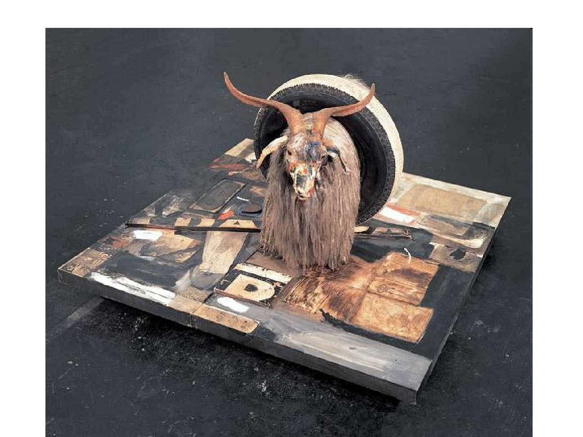
Monogram, 1955-59. Mixed mediums with taxidermy goat, rubber tire and tennis ball, ca. 42 x 63 x 65 in., Moderna Museet, Stockholm

